1.9.4

1. Ur2 = 5v  
   i = u / r  
   i = 5 / 1000 = 5mA
2. Utot = 10 – 5 = 5v  
   ur2 = 5 / 2 = 2.5v  
   ir2 = 2.5/1000 = 2.5mA  
   Maar het gaat de andere richting in dan de pijl dus -2.5mA

1.9.6 B

1.9.7 A

1.9.8 D

2.6.1

1. 250 ohm
2. 750 ohm (schatting) = 333 ohm
3. 225 ohm
4. 6k ohm (schatting) 8.47k ohm
5. 20 (schatting) = 6 ohm
6. 60k

2.6.2

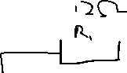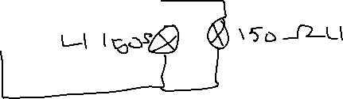

Rv = 75 + 12 = 87 ohm

2.6.3

1/Rv = 1/R1 + 1/R2 + 1/R3

Zie schrift

2.6.5

R = u / i  
u = 0.015  
i = 15  
R = 0,001 ohm

Extra opgave:

1. 45/9 + 5.5 ohm
2. 100 / (45/9 + 5.5) = 9.52
3. 9.52 \* (45/9 + 5.5) = 47.6V